Conjugated Polymer Nanoparticles as potential theranostic agents of
breast cancer
Panagiota Koralli¹, Spyridon Tsikalakis², Maria Goulielmaki¹, Stella Arelaki³, Janina Müller,^{2,4} Alkmini D. Nega⁵, Friederike Herbst³, Claudia R. Ball⁶, Vasilis G. Gregoriou⁷, Antonia Dimitrakopoulou-Strauss⁵, Stefan Wiemann², Christos L. Chochos¹

¹ Institute of Chemical Biology, National Hellenic Research Foundation, 48 Vassileos Constantinou Avenue, Athens, 11635, Greece
² Division of Molecular Genome Analysis, German Cancer Research Center (DKFZ), Im Neuenheimer Feld 580, 69120, Heidelberg, Germany
³ Translational Functional Cancer Genomics, National Center for Tumor Diseases (NCT) Heidelberg and German Cancer Research Center (DKFZ), 69120 Heidelberg, Germany
⁴ Faculty of Biosciences, University of Heidelberg, Im Neuenheimer Feld 234, 69120, Heidelberg, Germany
⁵ Clinical Cooperation Unit Nuclear Medicine, German Cancer Research Center, 69120 Heidelberg, Germany
⁶ Translational Medical Oncology, National Center for Tumor Diseases (NCT) Dresden and German Cancer Research Center (DKFZ) Heidelberg, 01307 Dresden, Germany
⁷ National Hellenic Research Foundation, 48 Vassileos Constantinou Avenue, Athens, 11635, Greece
Keywords: polymer dyes, bioimaging, conjugated polymers, nanoparticles, breast cancer, cytotoxicity

Introduction
Conjugated polymer nanoparticles (CPNs) have emerged as a new promising class of cancer theranostic agents due to their unique optoelectronic properties. In this study, nanoprecipitated and encapsulated aqueous CPNs were formulated consisting of thiophene–quinoxaline type conjugated polymers varying as regards the number of the fluorine atoms (three versus four) on the repeat unit. The obtained CPNs were systematically examined in terms of cytotoxicity and intracellular uptake in two different malignant human breast cell lines compared with a non-malignant epithelial cell line, whilst their ability to be used as potential cancer theranostic agents was evaluated.
Methods
To examine the cytotoxic effects of the CPNs on the cells depending on their preparation method, cell proliferation and late apoptotic cell numbers were evaluated. Confocal fluorescence microscopy and flow cytometry investigated the CPNs’ ability to be introduced to the cells and their potential application for intracellular imaging protocols. Moreover, to evaluate the potential therapeutic response of CPNs, we compared the cell proliferation and apoptosis results with those induced by the antibiotic staurosporine.

Discussion
The obtained results for the in vitro cell viability and cytotoxicity tests revealed that both the nanoprecipitated and the encapsulated T2fQ2f CPNs, as well as the nanoprecipitated T2fQf could potentially be used as FR/NIR fluorescent bioimaging dyes. However, FACS analysis and confocal microscopy confirmed that only the nanoprecipitated T2fQf CPNs could enter into the triple-negative, highly aggressive breast cancer cells with high efficacy and, to a lesser extent into the luminal type-A cells. Interestingly, we observed that these specific CPNs trigger apoptosis in cancer cells, and not in normal-like cells, making them an attractive candidate for further therapeutic intervention.
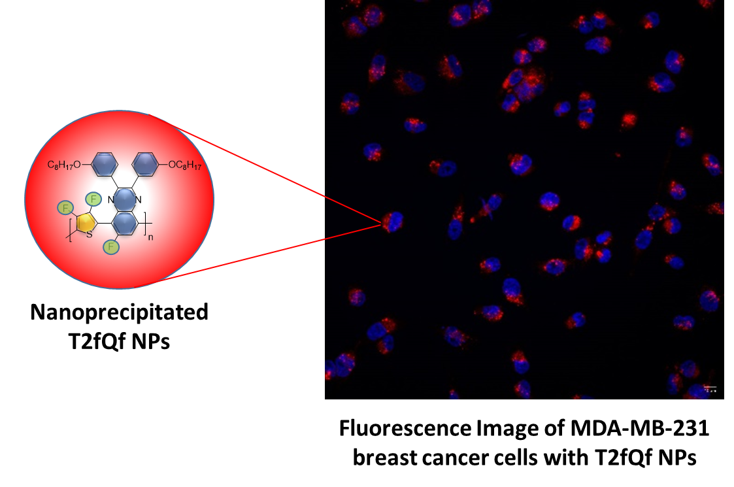
Scheme 1: Structure (left) and representative capture of cellular uptake (right) of T2fQf CPNs by confocal fluorescence microscopy. Merged confocal fluorescence images of cell nuclei (Hoechst/blue) and CPNs (red) were acquired after 24 h treatment of MDA-MB-231 cells with 0.176 mg/mL of nanoprecipitated T2fQf.

Conclusion
In this study, we presented one of the limited studies on the rational design of CPNs for specific biological purposes. The obtained results exhibit the potential of the CPNs to be used for bioimaging applications, as well as the putative therapeutic potential of the nanoprecipitated T2fQf CPNs.

Acknowledgement
Part of this research is co-financed by Greece and the European Union (European Social Fund- ESF) through the Operational Programme «Human Resources Development, Education and Lifelong Learning» in the context of the project “Reinforcement of Postdoctoral Researchers - 2nd Cycle” (MIS-5033021), implemented by the State Scholarships Foundation (ΙΚΥ).

References:
- P. Koralli, A. D. Nega, L.E. Vagiaki, A. Pavlou, M. Siskos, A. Dimitrakopoulou-Strauss, V. G. Gregoriou and C. L. Chochos “New Conjugated Polymer Nanoparticles with High Photoluminescence Quantum Yields for Far-red and Near Infrared Fluorescence Bioimaging”, Mater. Chem. Front., 2020, 4 (8), 2357-2369 (https://doi.org/10.1039/D0QM00195C)
- P. Koralli, S. Tsikalakis, M. Goulielmaki, S. Arelaki, J. Müller, A. Nega, F. Herbst, C. Baul, V. Gregoriou, A. Dimitrakopoulou-Strauss, S. Wiemann, C. Chochos, “Rational Design of Aqueous Conjugated Polymer Nanoparticles as Potential Theranostic Agents of Breast Cancer”, Mater. Chem. Front. 2021, (https://doi.org/10.1039/D1QM00479D)

