Gender Responses to Emotional Appeals in Advertising: Comparing Self-Reported Measures and Facial Expressions
Eirini Tsichlaª, Maria Voutsaª, Kostoula Margaritiª* and Leonidas Hatzithomasª
ªDepartment of Business Administration, University of Macedonia, Thessaloniki, Greece
*corresponding author Kostoula Margariti, kostmar88@gmail.com

Gender Responses to Emotional Appeals in Advertising: Comparing Self-Reported Measures and Facial Expressions

Abstract
Gender stereotypes are shown to influence males’ and females’ emotional responses by dictating socially acceptable behaviors that hinder emotional expressiveness. Employing an experimental design, this study examines gender differences in emotional responses to aggressive, warm and non-emotional advertising stimuli and compares their reported emotional reactions to the analysis of facial expressions, a measure less susceptible to social desirability. The results demonstrate that males report higher levels of happiness and lower levels of negative emotions for the aggressive ad, whereas females report higher levels of happiness for the warm ad. Both sexes report similar responses for the non-emotional ad. The results from the facial expression analysis paint a similar picture regarding females’ higher levels of happiness for the warm ad and their higher levels of sadness for the aggressive ad. The findings contribute to the literature that employs physiological measures for advertising research yielding important managerial and social policy implications.

Introduction
Emotional appeals in advertising is one of the most frequently used creative strategies. Considering that their effectiveness lies on consumers’ subjective reactions to emotions, understanding gender differences in affective responses can form the basis for the development of successful advertising messages (Schwarz, Hoffmann and Hutter 2015). Prior research has highlighted various gender reactions across different emotional appeals in advertising: For instance, women appear to be more receptive towards subtle advertisements that appeal to warmth and affection (Schwarz, Hoffmann and Hutter 2015) while men are more positive towards aggressive, violent and provocative advertisements (Swani, Weinberger and Gulas 2013).
These differences have been attributed to biological and most importantly social factors (Putrevu 2001; Weinberger et al. 2016). The paternalistic social standards have “constructed” a fragile, susceptible identity for women and a dominant, dynamic role for men (Meyers-Levy and Sternthal 1991). In this light, women learn to effortlessly express their emotions (Simon and Nath 2004), while men are told to oppress their emotions towards third parties, in order to maintain a strong social image (Gallois and Callan 1986). Research findings corroborate to the above pattern, as men avoid revealing that they are enjoying an advertisement that depicts warm emotions when they are watching it in the presence of others (Fisher and Dubé 2005). Nonetheless, there is no evidence on how women experience advertising appeals that are incompatible with the traditional female stereotype. The proposed study aims to navigate these waters and elucidate the nature of women's emotional reactions towards advertisements that display scenes of aggressiveness.
Τhe majority of the relevant literature has extensively used self-assessment questionnaires in order to capture the emotional experience of subjects during their exposure to advertising messages. Nonetheless, the limitations of these measures have been widely acknowledged, urging the need to focus on applied research in order to directly observe human behavior (Baumeister, Vohs and Funder 2007). Psycho-physiological methods cater for the weaknesses of self-evaluation measures as they shed light on the unconscious of subjects. In that sense, they record their physical reactions (such as facial expressions) that can hardly be manipulated by research subjects (Cacioppo and Petty 1985; Wang and Minor 2008). The proposed study aims to bridge this research gap, through the combined use of a self-evaluation questionnaire and facial expression analysis in order to trace whether the physical emotional reactions of participants during their exposure to emotional advertising stimuli coincide with their self-reports.
Therefore, the objective of this study is to address the following research questions:
a) What are the emotional reactions reported by men and women when they are exposed to warm, aggressive and emotionally neutral advertising stimuli?
b) What are the real emotions (as recorded by the analysis of facial expression) experienced by both genders, upon their exposure to warm, aggressive and emotionally neutral advertising stimuli?
Literature Review
Gender differences in the expression of emotion
The perception of gender differences in their emotional responses is one of the most dominant and commonplace stereotypes. “Everyone knows the prevailing emotion stereotype: She is emotional, he is not” (Shields 2002, 3). Numerous studies support that gender differences in terms of the expression of emotional experience are arising from the roles undertaken by men and women in the society (Eagly 1987; Wood and Rhodes 1992). According to the normative theory of Hochschild (1975), the differences between men and women in emotional reactions and expressiveness converge with gender specific beliefs of the underlying culture. Hence, gender stereotypes signify the way in which people should (or shouldn’t) feel and express under different circumstances. Thus, when emotional experience deviates from pre-specified rules, people are more inclined to manage and ultimately repress their feelings, in order to demonstrate a more appropriate emotional behavior.
Differences in social roles form the foundation of stereotypical beliefs about the expected emotional behaviors of men and women. Women are described as emotionally expressive and unstable, preoccupied not only with their own emotional world but with that of others as well (Bakan, 1966; Grossman and Wood 1993). On the other hand, contemporary male stereotypes are either linked with the desire for dominance and superiority or with the stoicism associated with the strict avoidance of behaviors that reflect sensitivity (Eagly, Wood and Diekman 2000; Fisher and Dubé 2005).
Hypotheses Development
Emotional appeals in advertising can be categorized in terms of valence as positive (e.g. warmth, love) and negative (e.g. guilt, aggression, shame, fear). Aggression covers a wide range of behaviors, situations and events that may cause harm and injury of varying sorts and differing magnitudes (Berkowitz 1993). On the other hand, warmth is defined as a positive, gentle and volatile emotion and as part of empathetic emotional response (Coke, Batson and McDavis 1978). Aaker and Bruzzone (1981) argue that warmth is associated to advertisements that are using sentimental, “family and friends” creative approaches, which attempt to make viewers feel good about themselves.
The relationship between emotional reactions and advertising evaluation is likely to be coloured by gender. Men have been found to prefer advertising scenarios that promote competitiveness and demonstrate authority (Prakash 1992) as well as more violent advertising scenarios than women (Swani, Weinberger and Gulas 2013). On the contrary, research evidence demonstrates that warm appeals are more effective in raising brand awareness and loyalty for women compared to men (Aaker and Stayman 1989; Geuens and de Pelsmacker 1998).
In addition, relevant studies reveal the existence of differences in the emotional expressivity of men and women that can be traced in the greater desire of men to adapt their emotional profile in what they consider to be appropriate or socially acceptable (Fischer and Manstead 2000; Fisher and Dubé 2005). In particular, men often experience emotions incongruent to the male stereotype in private conditions, but they avoid the expression of these very emotions when they are in the public sphere (Fisher and Dubé 2005). As far as women are concerned, research conducted by Borders, Hattie and Hoffman (2005) showed that women perceive the expressiveness and orientation towards others as a fundamental characteristic of their femininity, highlighting the influence of gender clichés on their responses.
Following the preceding analysis, gender reactions in emotional advertising appeals are expected to vary in terms of the type of appeal (aggression, warmth and non-emotional) and the congruence of the particular emotional appeal to the gender stereotype. Specifically, the incongruence between the appeal and the gender’s emotional stereotype would lead to lower levels of positive and higher levels of negative emotions.
H1: Males who are exposed to an aggressive advertising appeal will report more positive and less negative emotions compared to females
H2: Females who are exposed to a warm advertising appeal will report more positive and less negative emotions compared to males
Η3: No significant differences are expected in males’ and females’ emotional responses for the non-emotional advertising appeal
Although numerous studies have examined emotions using self-report questionnaires, it should be emphasized that these measures are subject to the influence of gender stereotypes and social desirability bias (Grossman and Wood 1993; Hess et al. 2000). In that sense, the strong tendency of people in presenting themselves favorably is likely to distort the information retrieved from such measures. Thus, participants may be unwilling to give an honest answer, providing information that reflects reality with less accuracy, due to self-defense or impression management concerns (Maccoby and Maccoby 1954). This phenomenon is known as social desirability bias and can be a critical issue in several research designs, as the presence of the researcher may invoke a desire to save face (Stodel 2015).
According to LaFrance and Banaji (1992), gender differences tend to occur in terms of emotional expressiveness rather than emotional experience. Thus, there is a possibility that the reported differences in emotional reactions between males and females is an illusion created by stereotypes so deeply engraved in popular culture, that can predispose participants’ answers (McRae et al. 2008). However, physiological tools such as facial expression analysis capture involuntary reactions not affected by social desirability (Maxian et al. 2013) and studies using such tools suggest the absence of differences between the two genders in terms of emotional experience (Katkin and Hoffman 1976; Kelly et al. 2008). Therefore, it would be reasonable to assume that facial expression analysis would suggest the absence of differences between the two genders such as:
H4: The effect of gender on positive and negative emotions will not be significant when participants’ emotions are captured through the analysis of facial expressions.
Methodology
Participants and Experimental Design
In order to test the research hypotheses a 2 (sex: male or female) × 3 (emotional appeal: warmth, aggression, non-emotional appeal) between-subjects experiment was conducted. The study recruited students from the Business Administration Department of the University of Macedonia in Greece. The experimental procedure in all three scenarios was identical. Two researchers (a male and a female) were present during the procedure. Participants were distributed in three experimental groups: the first group was exposed to a warm advertisement, the second group watched the aggressive advertisement, while the third experienced the non-emotional one. The total sample of the experiment comprised of 54 respondents (28 males). All subjects were instructed to watch the advertisement on a computer screen and then complete a questionnaire that measured their emotional reactions.
Stimulus Materials
For the purpose of the experimental procedure one TV commercial for a filter coffee brand was created by a professional advertising agency. The use of TV commercials has been qualified for the experiment, since they are able to express precisely the different emotional appeals, namely, warmth and aggression. In contrast, when static printed advertisements are used in experimental procedures for the study of advertising effectiveness, emotional variations tend to be very small (Weinberger and Gulas 1992).
The choice of the product was based on a pretest with 48 participants that were instructed to report their feelings regarding 14 different types of products. Coffee is a low involvement product that appeals to both sexes and was associated with both warmth and aggressiveness. In order to increase the ecological validity of the study, the coffee brand shown in the advertisement is an actual brand that is not available in Greece. Items measuring familiarity with the brand were included in the questionnaire in order to rule out potential bias due to existing attitudes and beliefs about the brand. Each advertisement was developed in three different versions (a warm, an aggressive, and a non-emotional version). The manipulation of the emotional appeals was based on the character that performed the main role in the scenario, so as to reflect typical stereotypical roles of his gender (i.e., Zawisza, Cinnirella and Zawadzka 2006). The choice of male stereotype roles followed the categorization used by Belkaoui and Belkaoui (1976), Mitchell and Taylor (1990) and Tsichla and Zotos (2016). Specifically, the aggressive ad depicted the stereotype of the “Frustrated Male”, the warm version portrayed the stereotype of the “Family Man” and the non-emotional ad showed the “Neutral” stereotype.
Measures
The emotional reactions triggered by the advertisements were measured by the 22-item scale developed by Holbrook and Batra (1987). The questions focused on emotions of happiness (positive emotion), sadness, anger and fear (negative emotions). These emotions can also be detected by the FaceReader 8.0 software. Manipulation checks of the emotional appeals of warmth and aggression were conducted using the items developed by Swani, Weinberger and Gulas (2013). All variables were measured using five-point Likert scales ranging from (1) “strongly disagree” to (5) “strongly agree.” During participants’ exposure to the advertisements, their facial expressions were recorded with the use of a computer camera and analyzed through FaceReader 8.0 (Noldus Information Technology) software in order to be compared with their responses provided in the self-reported questionnaires.

Results
Perceived warmth was higher for the warm ad (M = 3.72) compared to the non-emotional (M = 2.85, p = .038) and the aggressive (M = 2.86, p = .028) ad (F (2, 51) = 4.586, p = .015). Perceived aggressiveness was also higher for the aggressive ad (M = 3.1) than the non-emotional (M = 1.56, p< .001) and the warm ad (M = 1.13, p< .001) (F (2, 51) = 21.255, p< .001) which indicates a successful manipulation.
A 2 (sex: male or female) × 3 (emotional appeal: warmth, aggression, non-emotional) between-subjects multivariate analysis of variance (MANOVA) was conducted. Happiness, sadness, fear and anger were treated as dependent variables in order to test hypotheses H1-3 (Table 1).
INSERT TABLE 1 HERE
The MANOVA analysis indicates that the main effect of emotional appeal (F(8, 86) = 10.526, p < .001; Wilk’s Λ = .255; partial η²= .495) and gender (F(4, 43) = 6.92, p < .001; Wilk’s Λ = .608; partial η²= .392) was statistically significant.
The interaction effect of the type of emotional appeals and gender was also significant (F(8, 86) = 13.323, p< .001; Wilk’s Λ = .199; partial η²= .553). As initially assumed, this interaction also exerted a statistically significant effect on all emotions. In order to test the moderating effect of gender on emotional responses, planned contrasts were performed (Figure 1).
INSERT FIGURE 1 HERE
The findings reveal that in the case of the aggressive ad females express more sadness (p < .001; Figure 1b), anger (p < .001; Figure 1c), and fear (p < .001; Figure 1d) than males, while males express more happiness than females (p < .001; Figure 1a). Hence hypothesis H1 is supported. When exposed to the warm ad, females express higher levels of happiness than males (p < .001; Figure 1a), while no statistically significant differences were reported between genders on negative emotions (ps > .29). Therefore, H2 is partially supported. No statistically significant differences were reported between males’ and females’ emotional reactions for the non-emotional ad (ps > .33). Hence, hypothesis H3 is supported.
As far as the analysis of facial expressions is concerned, the interaction effect of the type of emotional appeals and gender also exerted a statistically significant effect on happiness (F (2, 46) = 10.793, p < .001) and sadness (F (2, 46) = 2.981, p = .061; Table 1). Specifically, when exposed to the warm ad, females show higher levels of happiness (p < .001; Figure 2a), whereas when exposed to the aggressive ad they demonstrate higher levels of sadness compared to males (p = .008; Figure 2b) As a result, H4 is partially supported.
INSERT FIGURE 2 HERE
Discussion
In line with prior findings (Geuens and de Pelsmacker 1998; Swani, Weinberger and Gulas, 2013), this study suggests that the main effects and the interaction effect of the type of emotional appeals and gender are statistically significant. Particularly, the research shows that an aggressive advertising appeal evokes higher levels of happiness and lower levels of sadness, fear and anger for males whereas a warm advertising appeal evokes higher levels of happiness for females. Similar to expectations, no significant differences were reported after participants’ exposure to the non-emotional advertising appeal. Finally, the facial expression analysis revealed that males and females portray similar responses towards the advertisements except for women, who generated higher levels of happiness for the warm ad and higher levels of sadness for the aggressive ad. It is interesting that although several women reported negative emotions such as anger and fear for the aggressive advertisement, such emotions were not evident in their facial expression analysis. This difference could be interpreted from a social desirability viewpoint, that dictates gender appropriate responses that coincide with their sensitive, fragile nature and an aversion for violence and aggression.
The findings draw important managerial implications that could benefit the marketers’ and advertisers’ effort to communicate with their target groups by highlighting the effectiveness of warmth and aggressiveness to evoke emotional reactions and by specifying these very emotions for men and women. In addition, the results indicate that aggressive appeals should be treated with caution if they are addressed to a female audience, as they instil negative affective responses and ultimately, may create a backlash against the sponsor of the message.
This study is place and context specific. First, only Greek respondents participated in the experiment, urging the need for a more demographically diverse study to enhance the generalizability of the findings. Second, the study employed a small sample of participants and thus constitutes a modest beginning for the thorough understanding of the subject area, that needs to be corroborated by studies with greater sample sizes.

References
Aaker, D. A., and D.E. Bruzzone. 1981. Viewer perceptions of prime-time television advertising. Journal of Advertising Research 21: 15-23
Aaker, D. A., and D.M. Stayman. 1989. What mediates the emotional response to advertising? The case of warmth. In Cognitive and affective responses to advertising, ed.Patricia Cafferata and Alice M. Tybout, 287-304. Lexinton, MA: Lexington.
Bakan, David. 1966.The Duality of Human Existence. Chicago, IL: Rand McNally
Barrett, L. F., L. Robin, P.R. Pietromonaco, and K.M. Eyssell. 1998. Are women the “more emotional” sex? Evidence from emotional experiences in social context. Cognition & Emotion 12: 555-578.
Baumeister, R.F., K.D. Vohs, and D.C. Funder. 2007. Psychology as the science of self-reports and finger movements: Whatever happened to actual behavior? Perspectives on Psychological Science 2: 396-403.
Belkaoui, A., and J. M. Belkaoui. 1976. A comparative analysis of the roles portrayed by women in print advertisements: 1958, 1970, 1972. Journal of Marketing Research 13: 168-172.
Berkowitz, Leonard. 1993. Aggression: Its causes, consequences, and control. New York, NY: McGraw-Hill Book Company.
Borders, L.D., J.A. Hattie, and R.M. Hoffman. 2005. Personal Definitions of Masculinity and Femininity as an Aspect of Gender Self-Concept. Journal of Humanistic Counseling, Education, and Development 44: 66- 83.
Cacioppo, J. T., and R.E. Petty. 1985. Physiological responses and advertising effects: Is the cup half full or half empty? Psychology & Marketing 2: 115-126.
Gallois, C., and V. Callan. 1986. Decoding emotional messages: Influence of ethnicity, sex, message type, and channel. Journal of Personality and Social Psychology 51: 755-762.
Coke, J. S., C.D. Batson, and K. McDavis. 1978. Empathic mediation of helping: A two-stage model. Journal of Personality and Social Psychology 36: 752-766.
Eagly, Alice H. 1987. Sex Differences in Social Behavior: A Social-Role Interpretation. Hillsdale, NJ: Erlbaum.
Eagly, A. H., W. Wood, and A.B. Diekman. 2000. Social role theory of sex differences and similarities: A current appraisal. In The developmental social psychology of gender, ed. Thomas Eckes and Hanns M. Trautner,123-174. New York: Psychology Press.
Fischer, A. H., and A.S. Manstead. 2000. The relation between gender and emotions in different cultures. In Gender and Emotion: Social Psychological perspectives, ed. Agneta H. Fischer,71-94. Cambridge: Cambridge University Press.
Fisher, R. J., and L. Dubé. 2005. Gender differences in responses to emotional advertising: A social desirability perspective. Journal of Consumer Research 31:850-858.
Geuens, M. and P. De Pelsmacker. 1998. Need for Cognition and the Moderating Role of the Intensity of Warm and Humorous Advertising Appeals. Asia Pacific Advances in Consumer Research 3: 74–80.
Grossman, M. and W. Wood. 1993. Sex differences in intensity of emotional experience: A social role interpretation. Journal of Personality and Social Psychology 65: 1010-1022.
Hess, U., S. Senécal, G. Kirouac, P. Herrera, P. Philippot, and R.E. Kleck. 2000. Emotional expressivity in men and women: Stereotypes and self-perceptions. Cognition & Emotion 14: 609-642.
Hochschild, A. R. 1975. The Sociology of Feeling and Emotion: Selected Possibilities. In Another Voice: Feminist Perspectives on Social Life and Social Science, ed. Marcia Millman and Rosabeth M. Kantor, 208–307. New York: Anchor Books.
Holbrook, M. B., and R. Batra. 1987. Assessing the role of emotions as mediators of consumer responses to advertising. Journal of Consumer Research 14: 404-420.
Katkin, E. S., and L.S. Hoffman. 1976. Sex differences and self-report of fear: A psychophysiological assessment. Journal of Abnormal Psychology 85: 607-610.
Kelly, M. M., A.R. Tyrka, G.M. Anderson, L.H. Price, and L.L. Carpenter. 2008. Sex differences in emotional and physiological responses to the Trier Social Stress Test. Journal of Behavior Therapy and Experimental Psychiatry 39: 87-98.
LaFrance, M. and M. Banaji. 1992. Toward a reconsideration of the gender-emotion relationship. In Emotion and Social Behavior, ed. Margaret S. Clark, 178-201. Thousand Oaks, GA: Sage.
Maccoby, E.E. and N. Maccoby. 1954. The Interview: A Tool of Social Science. In Handhook of Social Psychology Vol. I, ed. Lindzey Gardner, 449-487. Cambridge, MA: Addison-Wesley.
Maxian, W., S.D. Bradley, W. Wise, E.N. Toulouse. 2013. Brand love is in the heart: Physiological responding to advertised brands. Psychology & Marketing 30: 469-478.
McRae, K., K.N. Ochsner, I.B. Mauss, J.J. Gabrieli, and J.J. Gross. 2008. Gender differences in emotion regulation: An fMRI study of cognitive reappraisal. Group Processes &Intergroup Relations11: 143-162.
Meyers-Levy J. and B. Sternthal. 1991. Gender Differences in the Use of Message Cues and Judgments. Journal of Marketing Research28: 84-96.
Mitchell, P.C.N., and W. Taylor. 1990. Polarising trends in female portrayal in UK advertising. European Journal of Marketing 24:41-49.
Prakash, V. 1992. Sex roles and advertising preferences. Journal of Advertising Research 32: 43-52.
Putrevu, S. 2001. Exploring the origins and information processing differences between men and women: Implications for advertisers. Academy of Marketing Science Review10: 1-13.
Schwarz, U., S. Hoffmann and K. Hutter.2015. Do Men and Women Laugh About Different Types of Humor? A Comparison of Satire, Sentimental Comedy, and Comic Wit in Print Ads. Journal of Current Issues & Research in Advertising 36: 70-87.
Shields, Stephanie A. 2002. Speaking from the heart: Gender and the social meaning of emotion. UK: Cambridge University Press.
Simon, R. W., and L.E. Nath. 2004. Gender and emotion in the United States: Do men and women differ in self-reports of feelings and expressive behavior? American Journal of Sociology 109: 1137-1176.
Stodel, M. 2015. But what will people think?: Getting beyond social desirability bias by increasing cognitive load. International Journal of Market Research 57:313-322.
Swani, K., M.G. Weinberger, and C.S. Gulas. 2013.The impact of violent humor on advertising success: A gender perspective. Journal of Advertising 42: 308-319.
Tsichla, E., and Y. Zotos. 2016. Gender portrayals revisited: searching for explicit and implicit stereotypes in Cypriot magazine advertisements. International Journal of Advertising 35:983-1007.
Wang, Y. J., and M.S. Minor. 2008. Validity, reliability, and applicability of psychophysiological techniques in marketing research. Psychology and Marketing 25: 197–232.
Weinberger, M.G., and C.S. Gulas. 1992. The impact of humor in advertising: A review. Journal of Advertising 21: 35-59.
Weinberger, M.G, K. Swani, H.J. Yoon, and C.S. Gulas. 2016.Understanding responses to comedic advertising aggression: the role of vividness and gender identity. International Journal of Advertising 36: 562-587.
Wood, W., and N. Rhodes. 1992. Sex differences in interaction style in task groups. In Gender, Interaction, and Inequality, ed. Cecilia L. Ridgeway, 97-12. New York: Springer-Verlag.
Zawisza, M., M. Cinnirella, and A. M. Zawadzka. 2006. Non‐traditional male gender portrayal as a persuasion tool in advertising. Social Influence 1: 288-300.

Tables
Table 1: Descriptive statistics, mean (Standard Error) scores of manipulation measurements and dependent variables.
Dependent variables |  | Aggressive |  |  |  | Warm |  |  |  | Non-emotional
 |  | M | F | p-value |  | M | F | p-value |  | M | F | p-value |  | F - statistic
Happiness | SR | 2.79 (.2) | 1.17 (.2) | <.001 |  | 1.54 (.22) | 3.87 (.23) | <.001 |  | 1.42 (.21) | 1.13 (.23) | .362 |  | F (2, 46) = 44.734, p < .001
Sadness | SR | .94 (.11) | 1.79 (.11) | <.001 |  | .98 (.12) | 1.11 (.13) | .489 |  | 1.07 (.11) | .91 (.12) | .357 |  | F (2, 46) = 10.833, p < .001
Anger | SR | .95 (.11) | 2.31 (.11) | <.001 |  | .94 (.12) | 1.13 (.13) | .289 |  | 1.06 (.11) | .89 (.12) | .333 |  | F (2, 46) = 26.060, p < .001
Fear | SR | .98 (.12) | 1.72 (.12) | <.001 |  | .95 (.13) | 1.07 (.13) | .528 |  | 1.02 (.12) | .95 (.13) | .687 |  | F (2, 46) = 6.509, p = .003
Happiness | PM | .094 (.03) | .118 (.03) | .584 |  | -.013 (.04) | .299 (.04) | <.001 |  | .012 (.03) | .044 (.04) | .522 |  | F (2, 46) = 10.793, p < .001
Sadness | PM | .012 (.01) | .058 (.01) | .008 |  | .028 (.01) | .014 (.01) | .472 |  | .008 (.01) | .02 (.01) | .529 |  | F (2, 46) = 2.981, p = .061
Anger | PM | .174 (.03) | .111 (.03) | .176 |  | .046 (.04) | -.024 (.04) | .202 |  | -.031 (.03) | .047 (.04) | .151 |  | F (2, 46) = 2.319, p = .11
Fear | PM | .001 (.0) | .003 (.0) | .220 |  | .002 (.0) | .006 (.0) | .095 |  | .001 (.0) | .002 (.0) | .609 |  | F (2, 46) = .341, p = .713
N |  | 10 | 10 |  |  | 8 | 8 |  |  | 10 | 8
Note. All scale-items were on a 5-point Likert scale; SR – Self-report; PM – Physiological Measurement, M – Males, F – Females

Figures
Figure 1: Two-way interaction effects of self-report measurements (Hypotheses H1-3)
(a)
(b)
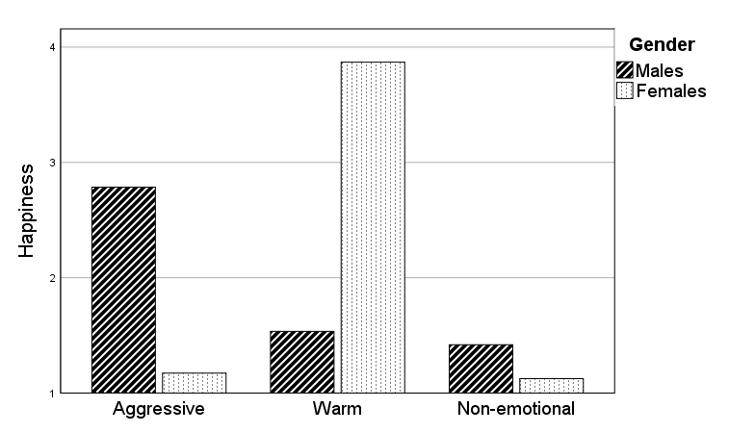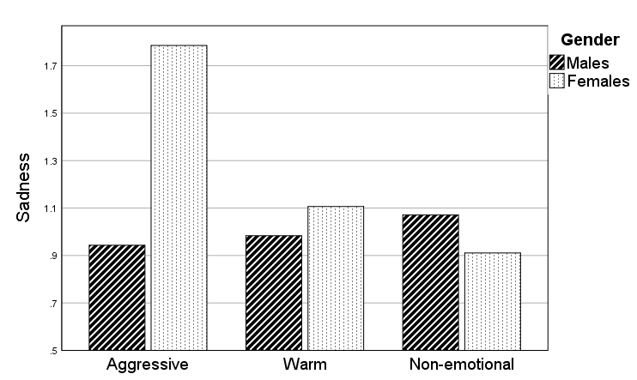
(d)
(c)

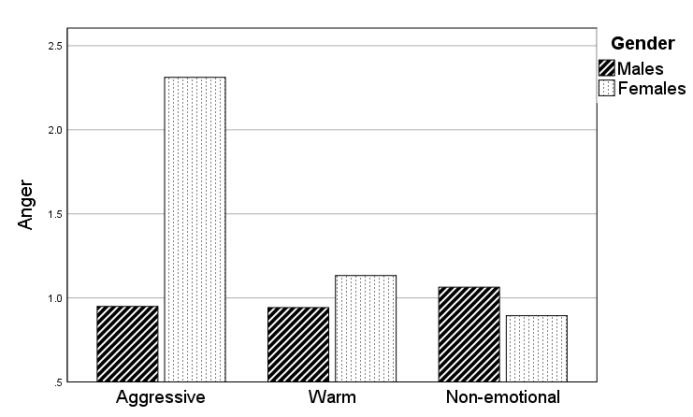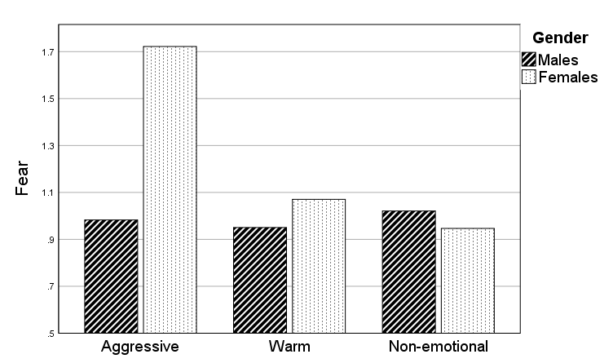

Figure 2: Two-way interaction effects of physiological measurements (hypothesis H4)
(b)
(a)

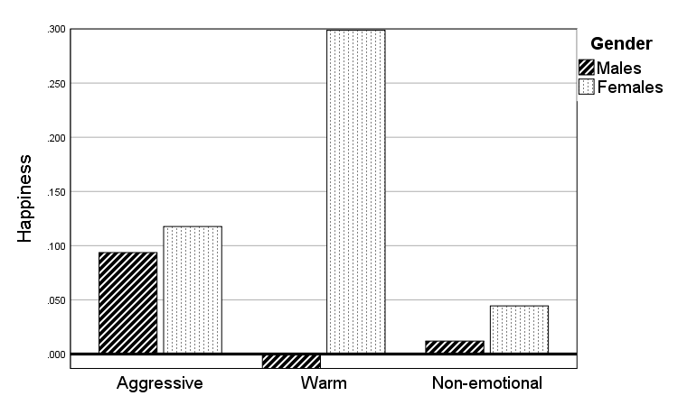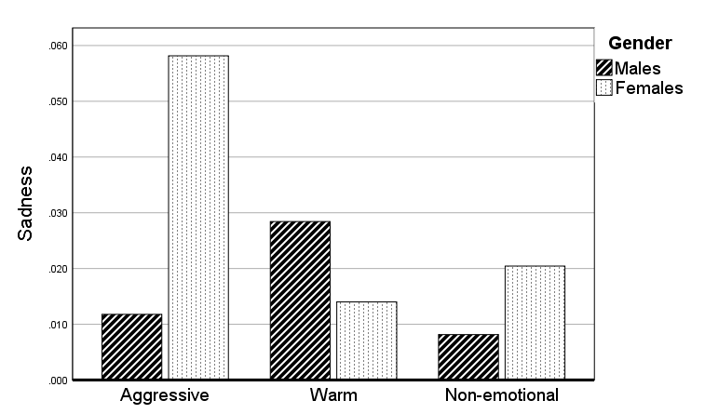

This study is co-financed by Greece and the European Union (European Social Fund) through the Operational Programme “Human Resources Development, Education and Lifelong Learning” (Partnership Agreement 2014-2020). The authors contributed equally to the present work.

